CSE301 Biocomputation, weeks 3, 2016
Week 3 Tutorial Exercises on Perceptron

Part 1. Answer the following questions
1. What is an artificial neuron? What is a McCullogh-Pitts neuron?

Answer: An artificial neuron is a very simplified model of brain neuron. For the McCullogh-Pitts artificial neuron, the inputs and outputs are binary (representing 2 states "active" or "inactive"), the synapse strength (connection between neuron via e.g. a neurotransmitter) is modeled by a weight, the "potential" of the neuron is modeled by a weighted sum of the inputs, and whether or not the neuron "fires" by the thresholded potential. Such an artificial neuron is a linear discriminant.

2. What is Hebb’s rule?

Answer: This is the simplest way of training an artificial neuron: the synapse between two neurons is reinforced if there is co-activity, or equivalently if for a given neuron its input is 1 and simultaneously its output is 1.
wj <- wj + xi y
For neurons with binary 0/1 states, the weight is updated only if positive activity takes place. But the rule can also be applied to "neurons" with +1/-1 states and for linear discriminant with continuous value inputs.
If there are the same numbers of examples in either class, a linear classifier f(x)=w.x+b trained with Hebb's rule classifies examples according to the nearest class centroid. It may classify the training examples with a few errors.

3. What is the “Perceptron”? What is the Perceptron algorithm?

Answer: The Perceptron is a linear discriminant invented by Rosenblatt in the sixties: f(x)=w. phi(x) +b. It may be trained with the Perceptron algorithm, which also applies to the simpler f(x)=w.x+b model. The Perceptron algorithm is like Hebb's rule, but updates are made only for misclassified examples. If training examples are "linearly separable" the Perceptron algorithm converges to a hyperplane separating the examples without error.

4. What is gradient descent?

Answer: Gradient descent is a method of optimization. Given a cost function (or risk functional) R[f] steps are made in the parameter space of f to decrease R[f] in the direction of the steepest local slope. The method converges to a local minimum of f. The error rate is the "natural" risk functional for classification problems. However, it cannot be optimized by gradient descent because of its discontinuities. It is often substituted by other risk functionals (the "Perceptron" risk, the mean-square-error, etc.). Those will be reviewed again in upcoming lectures.

Part 2. Tell whether each of the following statements is true or false
Q1. A perceptron is guaranteed to perfectly learn a given linearly separable function within a finite number of training steps
True

Q2. For effective training of a neural network, the network should have at least 5-10 times as many weights as there are training samples.
False

Q3. A single perceptron can compute the XOR function.
False

Q4.In a training set, no two items can have the same feature vector
False
Multiple items can have the same feature vector. Recall height and weight of a person

Q5. If a dataset is separable, it is separable with a hyperplane.

False

Q6. The perceptron convergence theorem says that if a hyperplane classifier exists, then the perceptron algorithm will find it
True

Q7. The perceptron can learn a classifier that has zero error on an infinite test set, with just a finite training set.
False

Q8.The perceptron algorithm can learn hyperplanes that do not pass through the origin.
True

Part 3. Consider the following questions for Perceptron:
A perceptron with a unipolar step function has two inputs with weights w₁ = 0.2 and w₂ = -0.5, and a threshold θ = -0.2 (θ can therefore be considered as a weight for an extra input which is always set to -1).

(a) Consider a task involving “a three-input, one-output parity detector” which outputs a 1 if the number of "1" inputs is even; otherwise it outputs a 0. Can this function be represented by a Perceptron? If so, construct a Perceptron that does it; if not, argue why not.

(b) The diagram below is about classifying a group of people according to whether they enjoy playing an Internet game () or not (). Each data point represents a person surveyed, and the axes represent the age (in years) and the salary (in hourly wages) of each respondent.
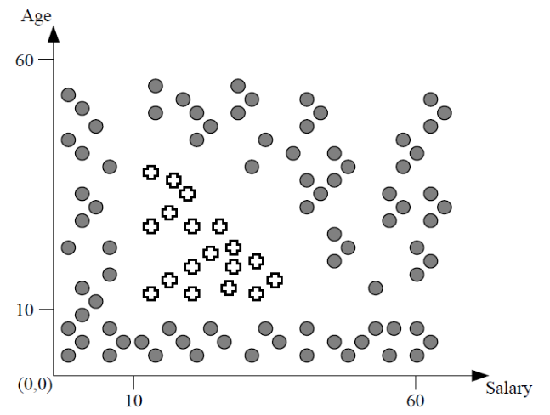
Figure 1
Can this data be classified using a feedforward neural network with no hidden layer? Explain why or why not.

Answer:
(a)
No, because it is not linearly separable. That is, in the figure below it can be seen that there does not exist a plane that puts all of the 1’s on one side and all of the 0’s on the other side.
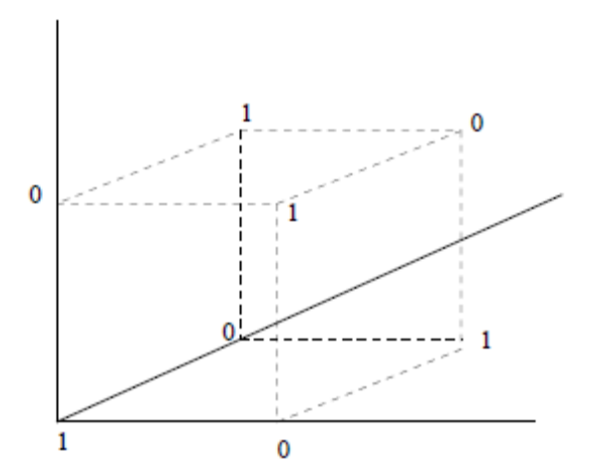

(b)
This data cannot be classified using a neural network with no hidden layer (a.k.a. a perceptron), because perceptrons are only able to classify data that has a linear separation boundary.

Part 4. Consider the following questions for Perceptron:
- Consider the following Boolean function
A | B | ¬A∨B
1 | 1 | 1
1 | 0 | 0
0 | 1 | 1
0 | 0 | 1

Can this function be represented by a perceptron? Explain your answer.

Answer: Yes, since the function is linearly separable:

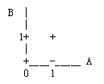

- If yes, construct a perceptron that represents the function. Otherwise construct a multilayer neural network that represents it.

Answer
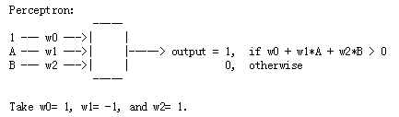

Part 5. What are the values of weights w0, w1, and w2 for the perceptron whose decision surface is illustrated in the figure? Assume the surface crosses the x1 axis at ‐1 and the x2 axis at 2.

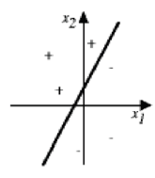
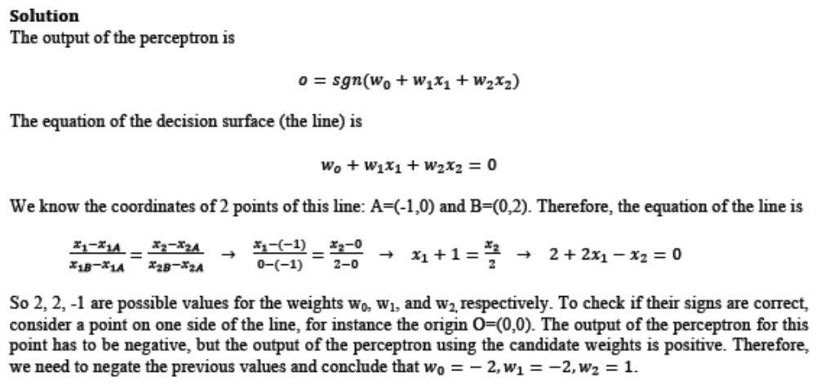
Part 6. The following Boolean functions take two Boolean features x1 and x2 as input. The features can take on the values −1 and +1, where −1 represents False and +1 represents True. The output y of the functions can also take on the values −1 and +1, with the same interpretation. For each of the functions below, either give weights
for a perceptron such that the perceptron represents the function or argue that no
such weights exist.

Hint: Draw pictures like on slides from the Monday class of week 3.

Solution
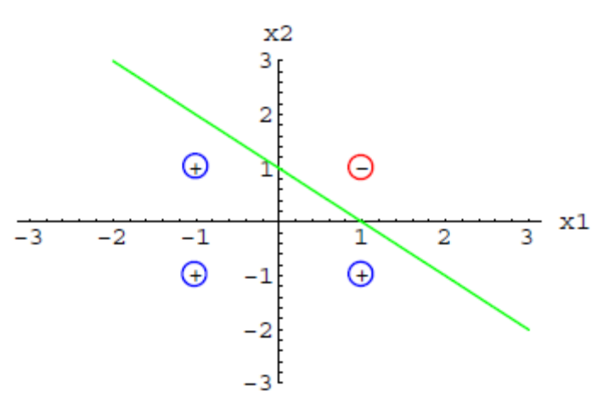
(a) A perceptron can represent this function using for example the weights w0 = 1,
w1 = −1, w2 = −1. Other answers are possible as well. In particular, all of these
weights multiplied by the same positive constant would give the same classifications.
Multiplication by a negative constant is not correct, however, because it inverts the
classifications made by the perceptron.
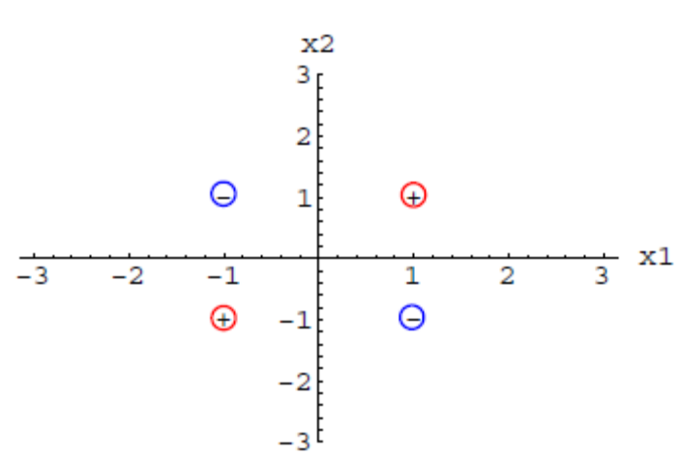
(b) No weights exist such that a perceptron represents this function, because the
pairs of inputs and corresponding outputs are not linearly separable.
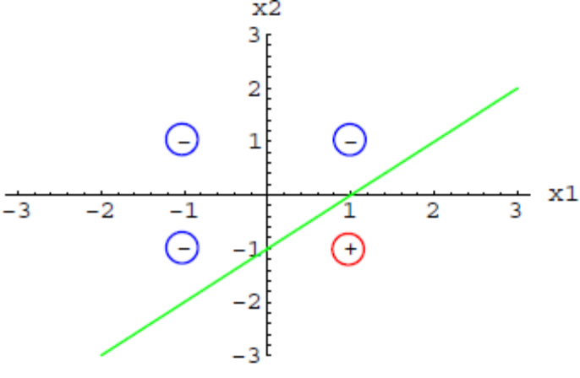
(c) A perceptron can represent this function using for example the weights w0 = −1,
w1 = 1, w2 = −1. Again, other answers are possible as well.

Part 7. Derive a gradient descent training rule for a single unit with output o, where

Solution:
